**High Level Flow diagram :**

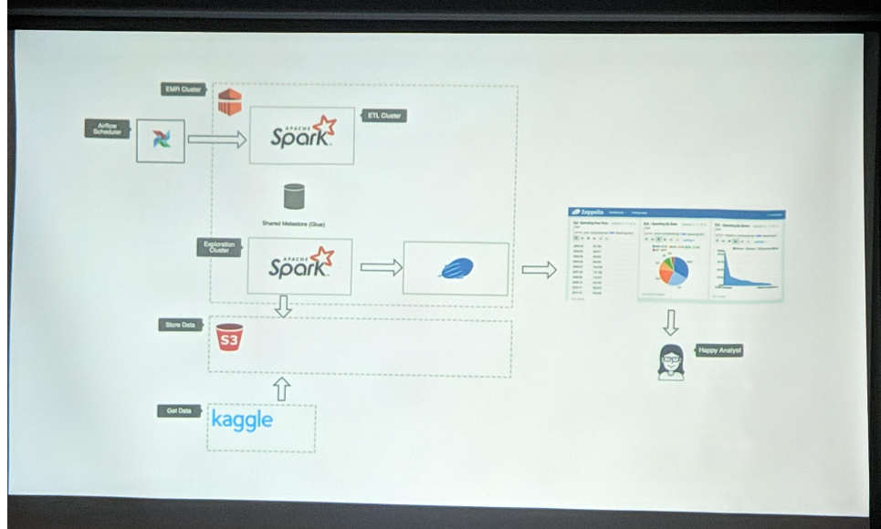

Reference documents:

<https://github.com/aws-samples/aws-emr-basketball-tool>

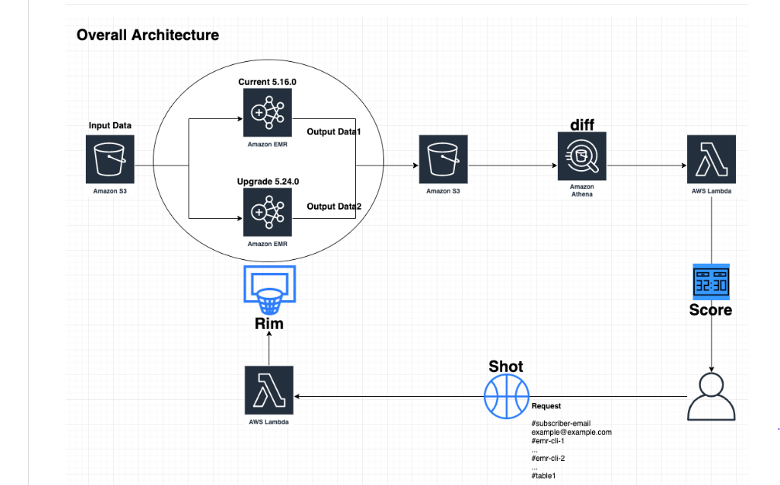

Reference document 2:

